Welcome to Korematsu Middle School Registration Day!
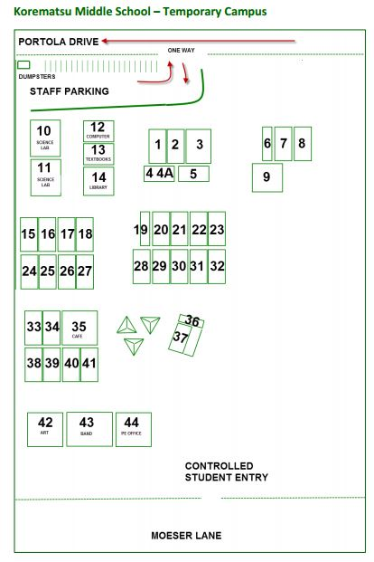
Today you will:
Step 1
A. Bring your registration materials from the packet that was mailed home to the Cafe (Room 35)
-Secondary School Code of Conduct and WCCUSD Technology Use Agreement
B. Also in the Cafe, you can sign your student up for free lunch and the after school program.
C. Visit the PTSA station at a table outside the Portola Cafe
-Turn in your PTSA membership form, Direct Appeal form, Parent Talent Search form
-Order or pick up your spirit wear
-Sign up for the etree
-Learn about volunteering at the school and for the PTSA
-Learn about Korematsu’s music program
Step 2
Go to Room 27 to get your student's class schedule. If you have questions/ concerns about the schedule please complete a schedule change request form and leave it in the box.
Step 3
Go to Room 26 to get your student's picture taken and acquire a student ID and lanyard. The student ID must be worn at all times on campus.
Step 4
Go to Room 25 to buy a Physical Education (PE) uniform ($22-$26 cash only), unless you will be providing your student with grey shirt and short/sweats from home.
Step 5
Go to Room 13 to get your student's textbooks. Please be sure to get your schedule before you get your textbooks.
Congratulations – You are done! See you on the first day of school!

